|  |
| --- |
| VENOM Studios |
| PHARAOH SLOTS |
| **[Slot Machine]** |
| Version #1.0  All work Copyright © 2012 by XX Games.  All rights reserved.  Andre Reano 101075780  Anto NanahJi 101103788  Logan King 101100360 |
|  |
|  |
|  |
|  |

|  |
| --- |
| May 16th 2012 |

**Table of Contents**

Page 3: Version History

Page 4: Game Overview, Game Mechanics, Camera, Controls, Interface

Page 5: Bonuses, sounds, art

**Version History**

<https://github.com/antoNanahJi/Android_SlotMachine_Game>

1. **Game Overview**

*Bet your money have fun and try to win the jackpot in this fun action filled slot machine game.*

1. **Game Play Mechanics**

Multiple betting Limits/Cool Visuals

1. **Camera**

*2D*

1. **Controls**

*Touch input on mobile*

1. **Interface Sketch**

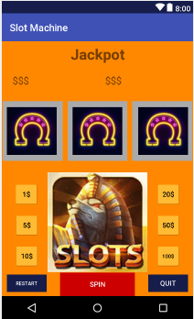

1. **Bonuses**

*Jackpot to fulfill your wishes*

1. **Sound Index**

*Spin, win, lose, jackpot sounds*

1. **Art / Multimedia Index**

*Neon classic slot machine graphics*

*Cool Pharaoh*